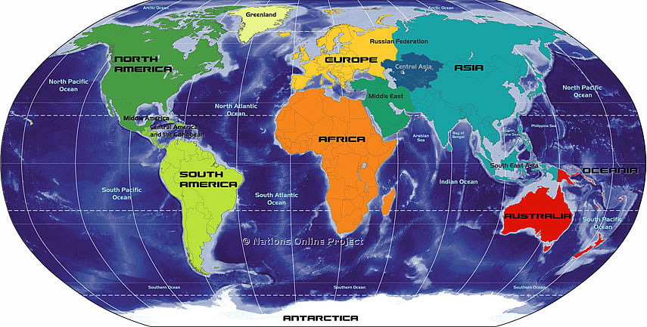
UNIT 1- 3 Weeks
1. Europe- identify on continents map
2. Africa- identify on continents map
3. Asia- identify on continents map
4. South America- identify on continents map
5. Antarctica- identify on continents map
6. North America- identify on continents map
7. Australia- identify on continents map
8. Atlantic Ocean- identify on oceans map
9. Pacific Ocean- identify on oceans map
10. Indian Ocean- identify on oceans map
11. Arctic Ocean- identify on oceans map
12. physical map- type of map that shows elevation, landforms, and water features
13. political map- type of map that shows borders, cities, and other human-made features
14. thematic map- type of map that shows specific topics in detail
15. physical characteristic- natural landforms and water features (rivers, oceans, mountains, valleys)
16. human characteristic- man-made features of the land (cities, buildings, streets, man-made lakes)
17. landforms- features of the land, like mountains and valleys
18.mantle- the layer of earth between the core and the crust, made up of magma and solid rock
19. core- the innermost layer of the earth
20. crust- thinnest, uppermost layer of the Earth
21. magma- hot, melted rock in the mantle that might flow to the surface during a volcano
22. ocean- one of the four major bodies of salt water that surround the continents
23. river- large natural stream of water that runs through the land.
24. lake- a large inland body of water
25. valley- area of low land between hills or mountains
26. tributary – a branch of a river
27. bay- part of a large body of water that extends into a shoreline, smaller than a gulf
28. gulf- part of a large body of water that extends into a shoreline, larger than a bay
29. isthmus- narrow stretch of land connecting two larger land areas
30. weathering- natural process that breaks rocks into smaller pieces
31. plate tectonics- theory that explains the location of the earth’s continents and how they have shifted over the years
32. earthquake- When two continental plates come together
33. solar system- The sun, planets, and stars
34. map scale- measuring line that shows how to figure out distance on a map
35. map key- code that explains the lines, symbols, and colors on a map
36. cardinal directions- North, South, East, West.
UNIT 2- 3 Weeks
37. import- to buy goods from another country
38. export- to sell goods to another country
39. (natural) resource- a product of the earth that people use to meet their needs
40. developed country- country with a lot of manufacturing , usually with a lot of technology, a high literacy rate, and a high life expectancy
41. developing country- country working toward industrialization, usually with low income levels, low literacy rates, and a short life expectancy
42. literacy rate- percent of people in a country that can read and write
43. life expectancy- the number of years an average person in a country is expected to live
44. culture- social groups, language, religion, daily life, history, arts, government, economy of a group of people, all are unifying elements
45. globalize- when countries become more interdependent, forming a world culture
46. interdependence- when countries are dependent upon one another for things like goods, services, and technology
47. non-renewable resource- natural resource like minerals that cannot be replaced
48. renewable resource- natural resource that cannot be used up or can be replaced naturally or grown again
49. democracy- government in which the leaders rule with permission of the people; leaders are elected by the people
50. monarchy- government in which a king or queen inherit the right to rule
51. dictatorship- government under the control of an all-powerful leader
52. market economy- based on the concept of free enterprise
53. command economy- based on the concept of socialism, the government owns the resources
54. cultural diffusion-the process of spreading new knowledge and skills to other cultures (ex: spread of ideas from the U.S. to the Middle East because of the internet)
55. culture region- different countries that have cultural traits in common (Ex: U.S. and Canada)
56. migration- the movement of people from place to place
57. urbanization- movement of people to cities
58. refugee- person who flees to a new country to escape danger
59. population density- average number of people living in a square mile or square kilometer
60. population distribution- how people are spread out
61. barriers to trade- tariffs (tax on imports) and quotas (limits on number of imports)
62. the most populated country- China
Unit 3- 3 Weeks
63. free enterprise system- an economic system in which people start and run business with little interference from the government.
64. representative democracy- Government in which the people are represented by elected leaders.
65. free trade- when goods flow freely between countries.
66. contiguous- an area joined inside a common boundary.
67. province- a regional political division in Canada. In the U.S., these would be called “states.”
68. bilingual- being able to speak two languages
69. colony- overseas settlement tied to a parent country
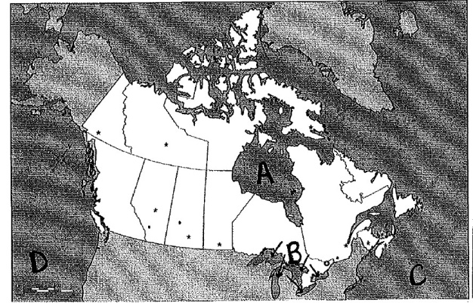
70. suburb- smaller community surrounding a city (ex: West Des Moines)

72. Pacific ocean- D
73. Great Lakes Region- B
74. Hudson Bay- A
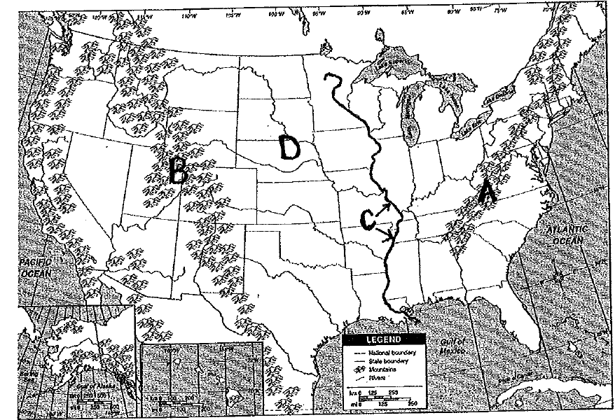
75. Atlantic Ocean- C
76. Appalachian Mountains----------------------------------------------> A
77. Great Plains ------------------------------------------------------------>D
78. Rocky Mountains ----------------------------------------------------->B
79. Mississippi River------------------------------------------------------->C
80. Subarctic climate- climate region with tundra and dense evergreen forests, short summers and bitterly cold winters

81. humid continental climate- climate region with hot, humid summers and cold, snowy winters, found in the Great Plains (including Iowa)

82. desert climate- climate region when hot, dry air gets trapped and there is very little rainfall

83. Prime Minister- Government leader in CANADA

84. President- Government leader in UNITED STATES

Unit 4- 3 weeks

85. Latin America- The Caribbean, Mexico, Central America, and South America

86. literacy rate- percent of people in a country that can read and write

87. Yucatan Peninsula- physical feature of Mexico

88. Andes Mountains- mountain range that runs along South America’s western coast

89. Amazon River Basin- found in South America

90. Pampas- large, treeless, grass-covered plains in South America (Argentina)

91. Amazon Rainforest- world’s largest rainforest, in danger of deforestation, home of millions of different plant and animal species

92. tourism- one of the most important economic activities in the Caribbean today

93. Atacama desert- major desert of South America

94. Cuba- large communist island that is part of the Caribbean Islands

95. deforestation- cutting down trees and not replacing them

96. temperature depends on 2 things- latitude and altitude

97. tropics- low latitude region between the Tropic of Cancer and the Tropic of Capricorn; the Caribbean Islands are located here

98. major religion of Latin America- Roman Catholic

99. major language of Latin America- Spanish

100. Aztec, Maya, and Inca- ancient Indian civilizations that influenced the culture of Latin America

101. Puerto Rico- Caribbean island that is a territory of the United States

Unit 5- 5 Weeks
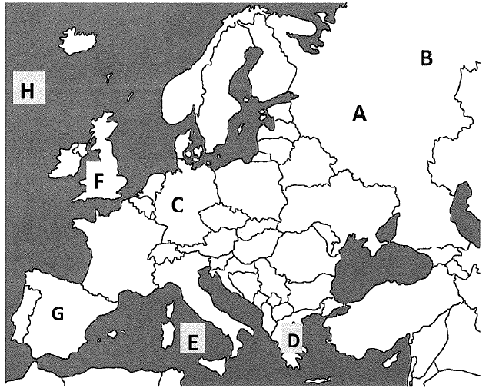
102. Russia- A

103. Ural Mountains- B

104. Germany- C
105. Greece- D
106. Mediterranean Sea- E
107. United Kingdom- F
108. Spain- G
109. Atlantic Ocean- H
110. Greece- country where the first democratic constitution was written
111. Coliseum- one of the major achievements of ancient Rome
112. feudalism- political and social system in which nobles were granted land from a lord to work, govern, and defend. In return, the noble provided loyalty to the lord
113. serf- A farm laborer who can be bought and sold with the land he/she works
114. Renaissance- time period in Europe characterized by a renewed focus on arts and literature and the beginning of modern science (included artists such as Leonardo da Vinci, Michelangelo Buonarotti, William Shakespeare
115. Lutheran Reformation- protest of the Catholic Church resulting in the creation of the Lutheran faith
116. Revolution- a great change- (ex. United States had a revolution against Great Britain, Great Britain had a revolution where the king and queen end up sharing power with Parliament)
117. Industrial Revolution- the major change in the 1700’s which included the introduction of machines to do work instead of manual labor
118. genocide- the deliberate killing of a specific group of people (Ex: The Holocaust)
119. Cold War- caused because of competition between the United States and the Soviet Union (USSR) after WWII
120. czar- name for emperor in Russia’s past
121. communism- type of political, social, and economic system where businesses and farms are owned by the government
122. Democracy-government in which the government rules with the permission of the people; leaders are elected

